Lab manual – S3 – Web Hosting

Objective.

TO create Web Site on S3

**Steps:**

1. Create bucket
2. Enable Web Hosting
3. Upload the index.html or error.html in the Bucket
4. Observe the output
5. Remove public access to the index.html
6. Create bucket

The bucket is created in “**N.Virginia”**

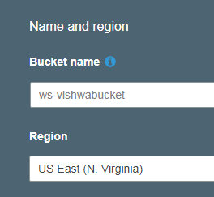 🡪 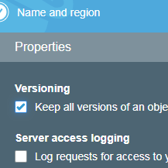 🡪

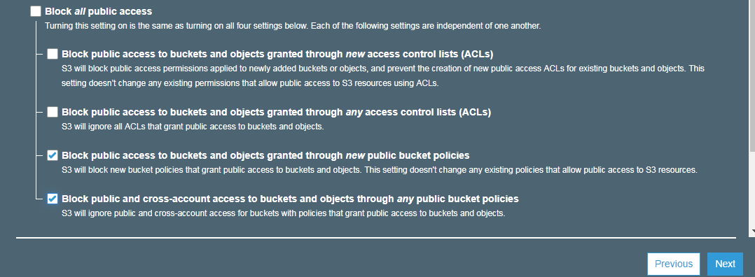

Now Click on “Create bucket”.

Make sure the “**Versioning**” is enabled and the bucket is having Public access as it would be for web hosting.

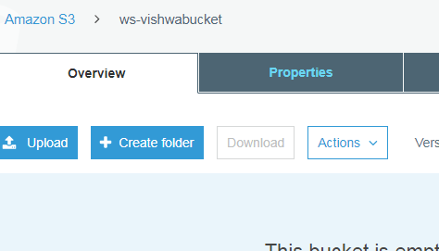

1. Enable Web Hosting

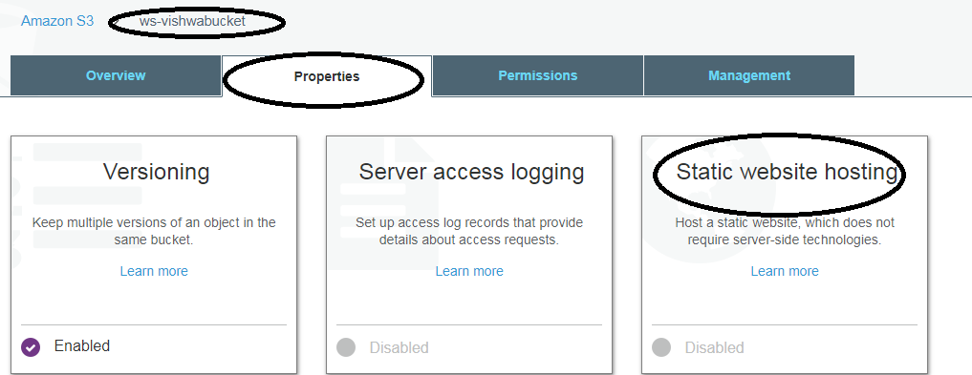

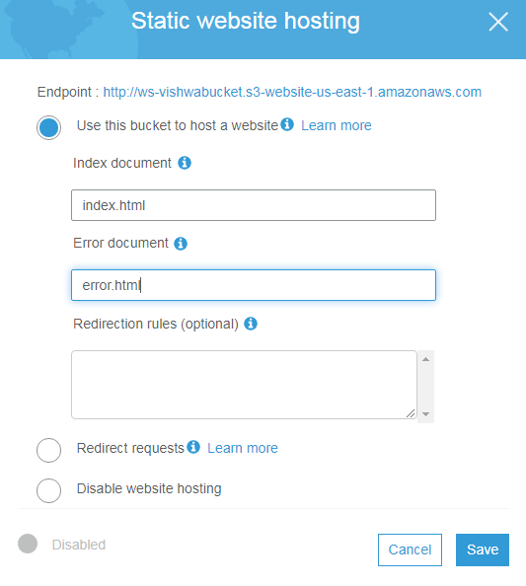

***index.html*** file for the First page of the website to be stored in the main path of bucket.

***error.html*** *–* if the index file is missing then this would show up.

Note: -- the files are case sensitive.

So, whatever file name you are uploading, make sure it’s the same here.

Click on “**save**”.

The link for the website access is on the top of this above image.

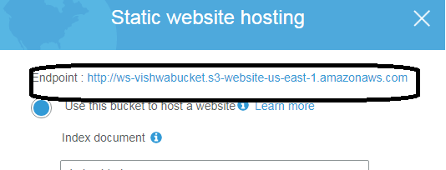

Use this link on the web browser , to access the website.

But, we still need to upload the files.

Just Hold…..

1. Upload the index.html or error.html in the Bucket

Create **index.html**

We will be using **.html** format of file only for this lab.

Html 🡪 is one of the easy way to code a website

Carefull about the **case** of the file name

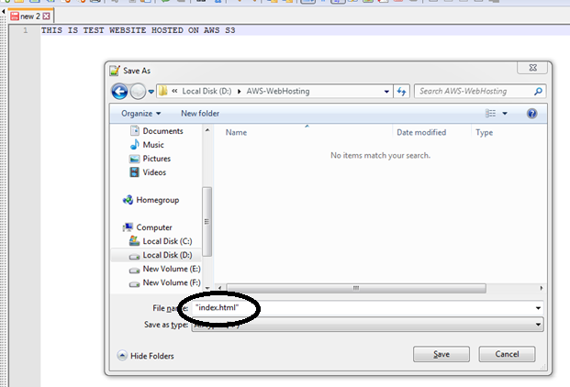

Now, create **error.html**

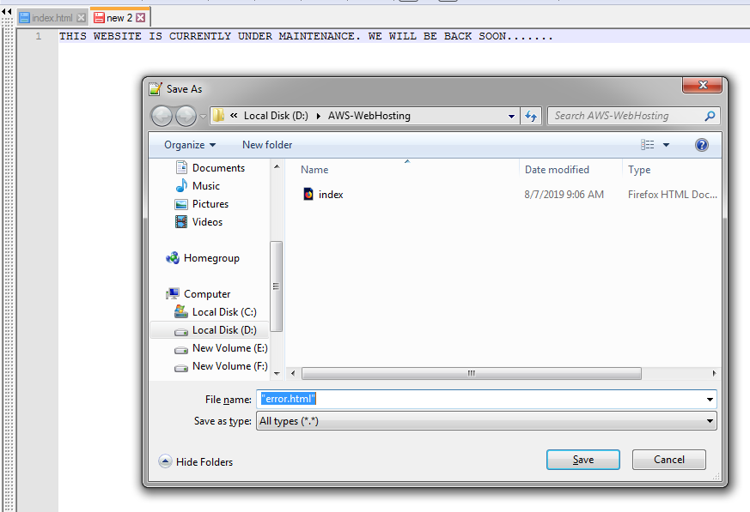

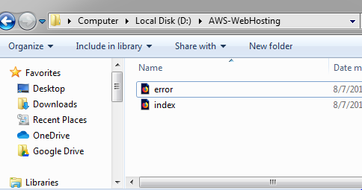

Now upload both the files in to the new S3 bucket with **“public” access.**

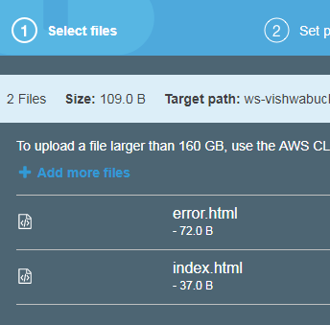 **🡪** 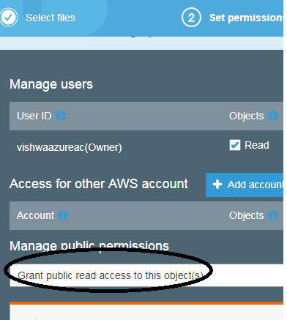

Any Storage class is fine. And upload.

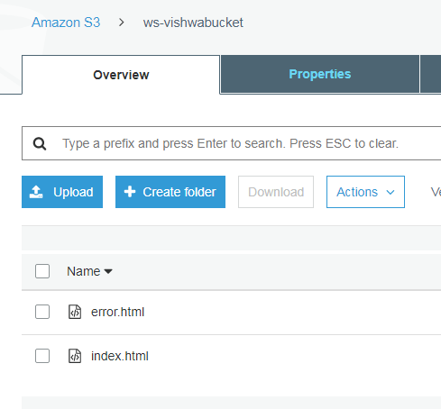

1. Observe the output

Lets use the website link



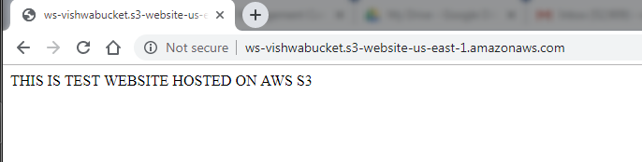

**The website is up and running.**

1. Remove public access to the index.html

Now let’s remove the public access to the index.html

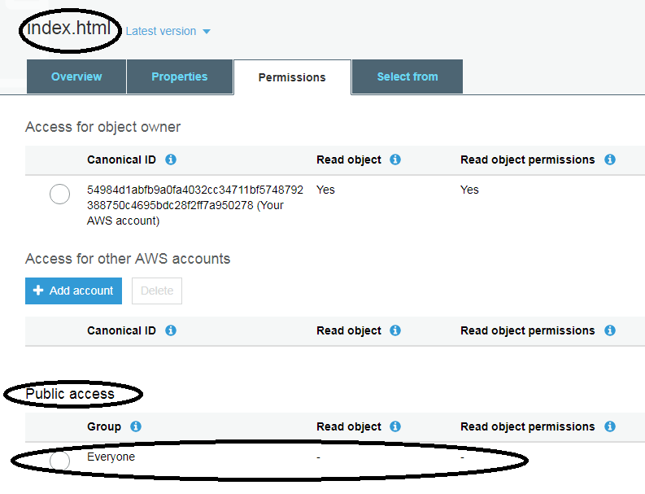

I have removed the “read Object” by unticking the option below.

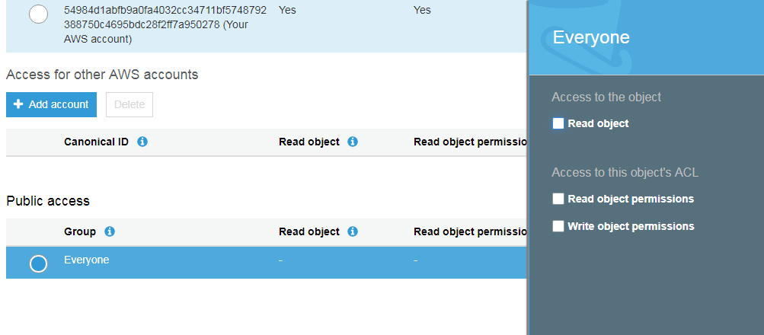

Now, lets observe the output.

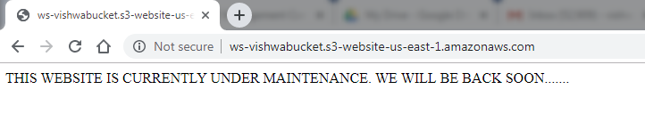

This is now showing the “**error.html**” page.

Which means it is switching over to another page as the **index.html** is no more public.

An easy method to host a basic website for FREE. :)